**WEB ENGINEERING Course Instructor: Razi Ahmad Date: 22-12-2017 LAB 10 JSPSERVLETS**

**Note:**

* Student collaboration is not allowed.
* Copying from or looking at solutions from other sources is strictly prohibited.
* Violations will not be excused and may result in an F in the course.
* Stay honest.

Task 1 [15]

* Design an HTML/JSP page that take Ask the user for a color name in a JSP
* Display "Hello World" in the chosen color using a servlet

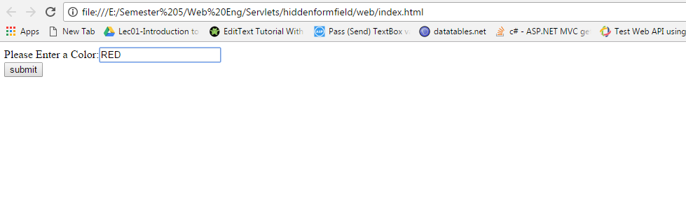

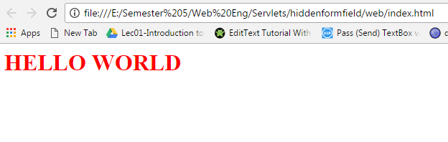

Task 2: [15]

* Design an HTML/JSP page that take Ask the user for fill a form of his personal information like (first name, last name, DOB, Gender, email) validate all of his information before submitting.
* On submit write all of this information in to file call “info.txt” in proper format by using Servlet.

Task 3: [10]

* Design an HTML/JSP page that take Ask the user for first name.
* On submit Search entered first name into file call “info.txt” and display all of his information on screen in proper format. (Assume first name of all user is unique).